# PyTorch

查看NVIDIA GPU驱动版本

watch -n1 nvidia-smi

查看CUDA toolkit

nvcc -v

conda update conda

conda update anaconda

conda update python

conda update --all

conda config --add channels <https://mirrors.tuna.tsinghua.edu.cn/anaconda/pkgs/free/>

conda config --add channels https://mirrors.tuna.tsinghua.edu.cn/anaconda/pkgs/main/

conda config --add channels https://mirrors.tuna.tsinghua.edu.cn/anaconda/cloud/pytorch/

conda config --add channels https://mirrors.tuna.tsinghua.edu.cn/anaconda/cloud/conda-forge/

conda config --add channels https://mirrors.tuna.tsinghua.edu.cn/anaconda/cloud/msys2/

conda config --set show\_channel\_urls yes

conda config --remove channels https://mirrors.tuna.tsinghua.edu.cn/anaconda/cloud/conda-forge/

conda config --show

conda create –n pytorch python=3.6

conda activate pytorch

conda deactivate pytorch

conda install pytorch torchvision torchaudio cudatoolkit=10.2 –c pytorch

python

import torch

print('gpu:', torch.cuda.is\_available())

# Sekiro

conda create –n sekiro python=3.7

conda activate sekiro

查看tensorflow-gpu与cuda的适配版本

<https://tensorflow.google.cn/install/source?hl=en#linux>

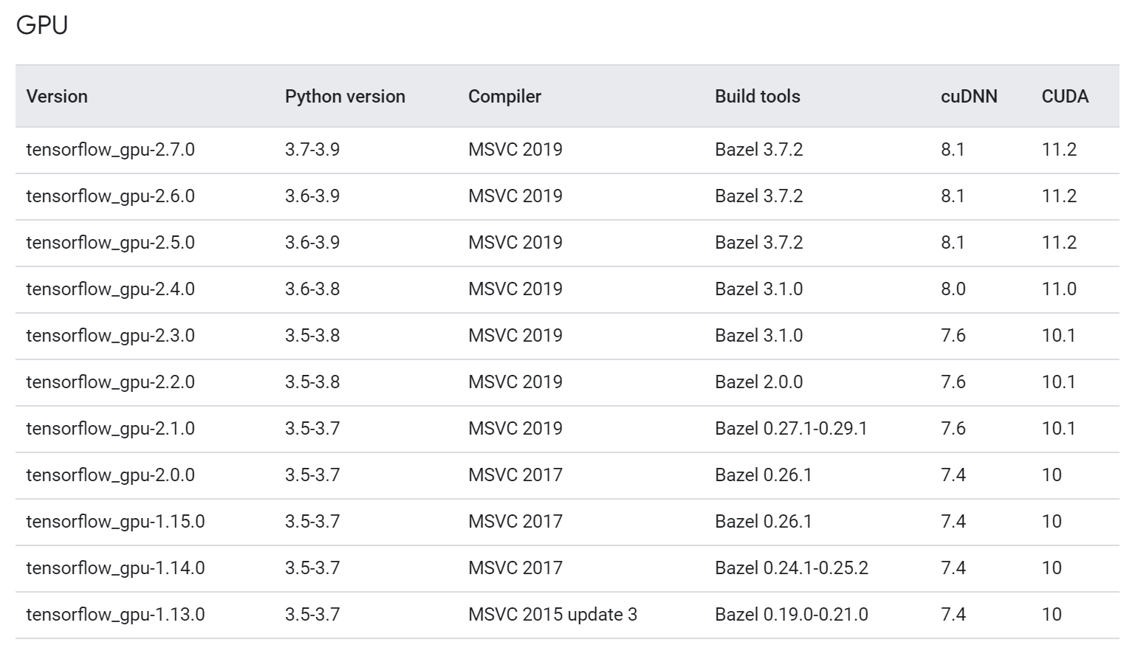

CUDA 10.2

cuDNN 7.6

conda search tensorflow-gpu

conda install tensorflow-gpu=2.3.0 –y

conda install opencv=4.5.3

conda install pillow

conda install pywin32

conda install gym=0.18.0

conda install flask

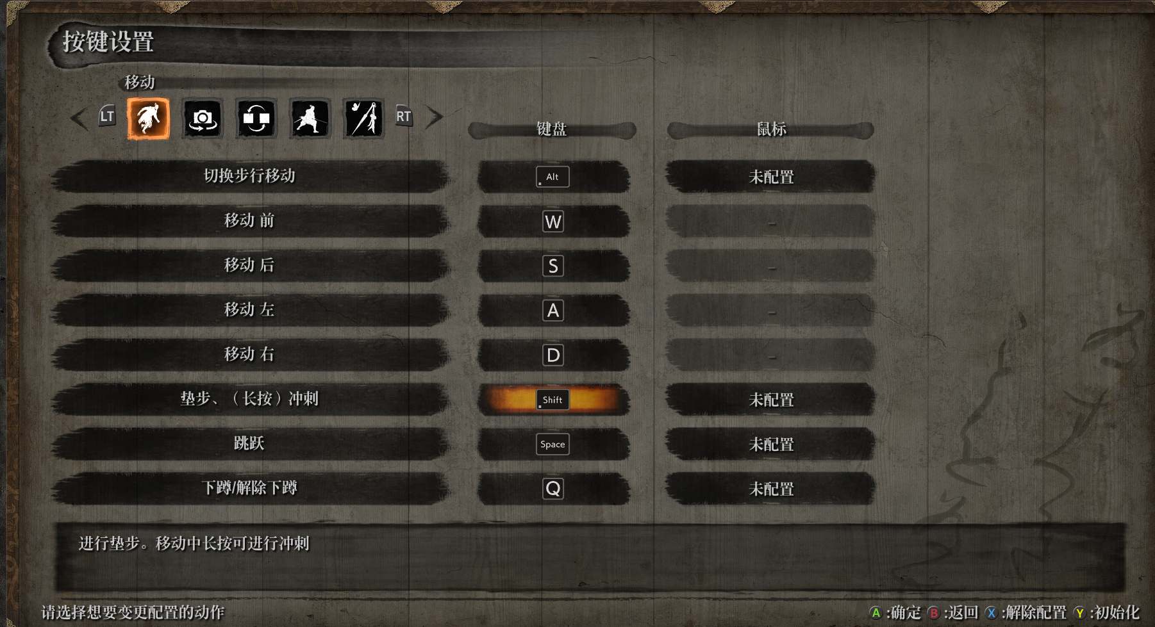

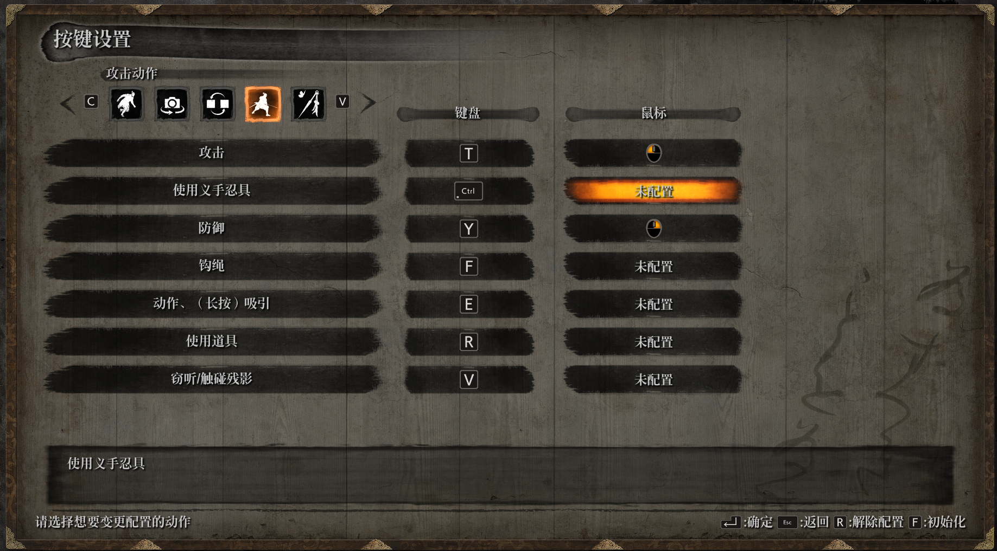

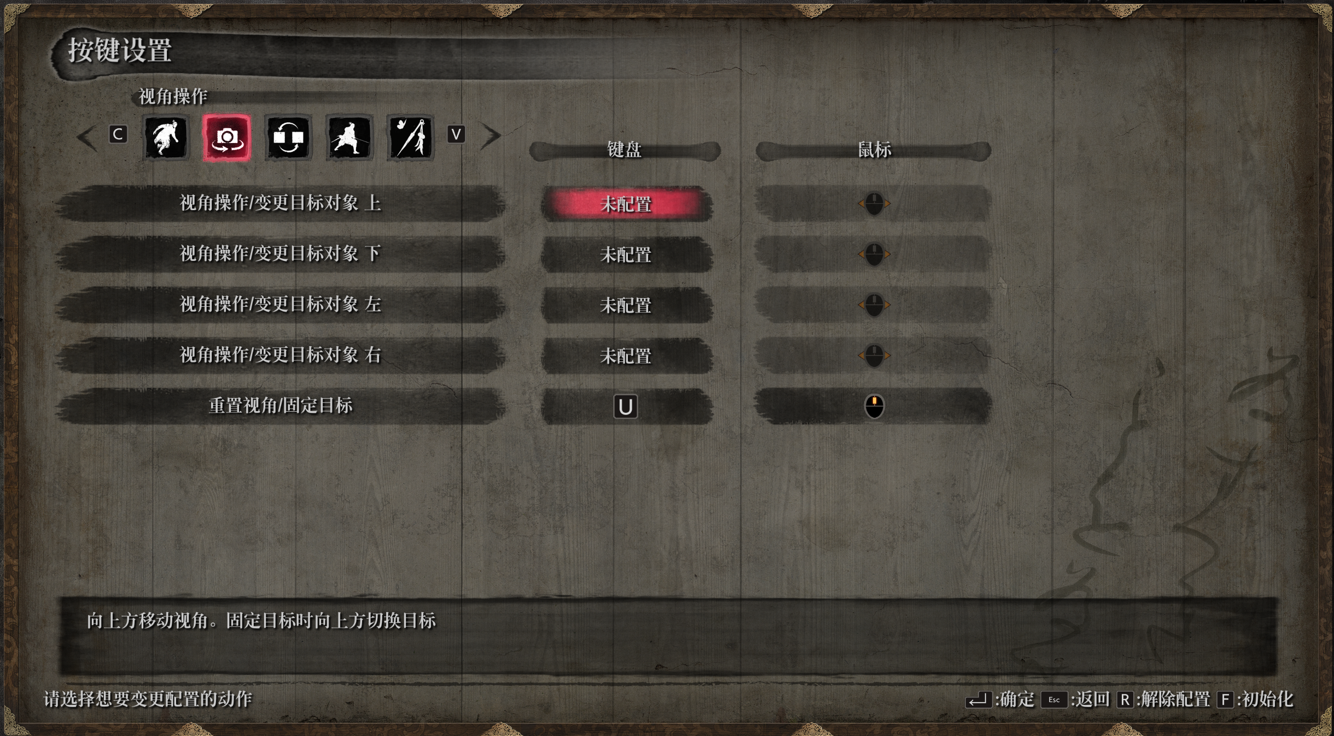

存档文件位于

C:\Users\Administrator\AppData\Roaming\Sekiro

## Troubleshooting

在运行具有使用tensorflow 2.0的代码的kubeflow管道时。在每个时期结束时显示以下错误

W tensorflow / core / kernels / data / generator\_dataset\_op.cc：103]最终确定GeneratorDataset迭代器时发生错误：已取消：操作已取消

另外，在某些时期之后，它不显示日志并显示此错误

该步骤处于失败状态，并显示以下消息：节点资源不足：内存。容器主容器正在使用100213872Ki，它超出了其0的请求。容器等待正在使用25056Ki，它超出了其0的请求。

这是由于不兼容的CUDA和Tensorflow版本。以下版本相互配合良好

张量流gpu == 2.0.0

tensorflow-addons == 0.6.0

NVIDIA / CUDA：10.0-cudnn7-运行时

## [Linux下为python3安装opencv](https://www.cnblogs.com/yangruicvpr/p/9578947.html)

1.到opencv官网[https://opencv.org/releases.html](https://opencv.org/releases.html" \t "_blank)下载需要的opencn安装包，如opencv-3.4.2，解压

unzip opencv-3.4.2.zip

2.进入该文件夹

   cd opencv-3.4.2

3.建立文件夹release

 mkdir release

4.安装依赖

   sudo apt-get install build-essential cmake libgtk2.0-dev pkg-config python-dev python-numpy libavcodec-dev libavformat-dev libswscale-dev

5.进入release并编译

   cd release

   cmake -D CMAKE\_BUILD\_TYPE=RELEASE -D CMAKE\_INSTALL\_PREFIX=/usr/local ..

6.安装

  sudo make install

conda install requests

conda install beautifulsoup4

conda install tqdm

conda install pandas

conda install matplotlib

pip3 install jieba

pip3 install wordcloud

fc-list :lang=zh查看mac字体

# Pandas解决csv中文乱码问题

Python保存csv文件使用utf-8编码后使用excel打开中文会乱码

使用pandas的read\_csv读取后再用to\_csv保存文件并设置“encoding=utf\_8\_sig”即可解决

import pandas as pd

path = ’report\_utf8.csv’

data = pd.read\_csv(path,)

data.to\_csv(‘result\_utf8\_with\_bom.csv’, encoding=’utf\_8\_sig’)

# ROS

## 连接AWS EC2 Linux instance Ubuntu远程桌面

创建了AWS EC2 Linux instance Ubuntu，记录下通过本地Windows远程访问AWS Ubuntu桌面的方法。

1, 更新，升级和安装准备

sudo apt-get update

sudo apt-get upgrade

2，配置sshd\_config允许密码访问

sudo emacs /etc/ssh/sshd\_config

将 PasswordAuthentication 选项设置为yes

# Change to no to disable tunnelled clear text passwords

#PasswordAuthentication no

PasswordAuthentication yes

3,重启SSH伺服让配置生效

sudo /etc/init.d/ssh restart

4，为用户名ubuntu设置密码

sudo –i

passwd ubuntu

su ubuntu

5，为Ubuntu Linux Instance安装桌面功能

大概需要十多分钟，

export DEBIAN\_FRONTEND=noninteractive

sudo -E apt-get update

sudo -E apt-get install -y ubuntu-desktop

6，安装XRDP和其它xfce4资源

sudo apt-get install xfce4 xrdp

sudo apt-get install xfce4 xfce4-goodies

7，设置xfce4为RDP连接的默认window manager

echo xfce4-session > ~/.xsession

8，拷贝.xsession 到 /etc/skel 目录

这样新的用户名被创建的时候，xfce4 自动被设置为默认的 window manager

sudo cp /home/ubuntu/.xsession /etc/skel

9，修改/etc/xrdp/xrdp.ini配置文件

当进行远程连接时允许改变主机端口，在 [xrdp1]区

port=-1

改为：

port=ask-1

10，重启xrdp

sudo service xrdp restart

11，在本地Windows端进行连接

打开Remote Desktop Connection,

输入Public DNS,点连接，

在“Login to xrdp”界面输入sesman-Xvnc， ubuntu和先前设置的密码，端口设置为-1，点OK

连接成功如下图所示：

参考链接：

1, Connect to an Amazon EC2 Linux instance with desktop functionality from Windows

2, How-to-set-up-gui-on-amazon-ec2-ubuntu-server

## ROS1 install

* sudo sh -c 'echo "deb http://packages.ros.org/ros/ubuntu $(lsb\_release -sc) main" > /etc/apt/sources.list.d/ros-latest.list'
* sudo apt install curl # if you haven't already installed curl
* curl -s https://raw.githubusercontent.com/ros/rosdistro/master/ros.asc | sudo apt-key add -
* sudo apt update

**Desktop-Full Install: (Recommended)** : Everything in **Desktop** plus 2D/3D simulators and 2D/3D perception packages

* sudo apt install ros-noetic-desktop-full
* To find available packages, see [ROS Index](https://index.ros.org/packages/page/1/time/#noetic) or use:
* apt search ros-noetic

echo "source /opt/ros/noetic/setup.bash" >> ~/.bashrc

source ~/.bashrc

To install this tool and other dependencies for building ROS packages, run:

sudo apt install python3-rosdep python3-rosinstall python3-rosinstall-generator python3-wstool build-essential

sudo apt install python3-rosdep

With the following, you can initialize rosdep.

sudo rosdep init

rosdep update

## Create a ROS Workspace

$ mkdir -p ~/catkin\_ws/src

$ cd ~/catkin\_ws/

$ catkin\_make

**Python 3 users in ROS Melodic and earlier**: note, if you are building ROS from source to achieve Python 3 compatibility, and have setup your system appropriately (ie: have the Python 3 versions of all the required ROS Python packages installed, such as catkin) the first [catkin\_make](http://wiki.ros.org/catkin/commands/catkin_make) command in a clean [catkin workspace](http://wiki.ros.org/catkin/workspaces) must be:

$ catkin\_make -DPYTHON\_EXECUTABLE=/usr/bin/python3

$ source devel/setup.bash

$ echo $ROS\_PACKAGE\_PATH

/home/youruser/catkin\_ws/src:/opt/ros/kinetic/share

## Navigating the ROS Filesystem

$ rospack find roscpp

$ roscd roscpp

# You should have created this in the Creating a Workspace Tutorial

$ cd ~/catkin\_ws/src

$ catkin\_create\_pkg beginner\_tutorials std\_msgs rospy roscpp

$ cd ~/catkin\_ws

$ catkin\_make

$ . ~/catkin\_ws/devel/setup.bash

## Quick Overview of Graph Concepts

$ sudo apt-get install ros-<distro>-ros-tutorials

$ roscore

$ rosnode list

$ rosnode info /rosout

$ rosrun turtlesim turtlesim\_node

$ rosrun turtlesim turtlesim\_node \_\_name:=my\_turtle

$ rosrun turtlesim turtle\_teleop\_key

### Using rqt\_graph

rqt\_graph creates a dynamic graph of what's going on in the system. rqt\_graph is part of the rqt package. Unless you already have it installed, run:

* $ sudo apt-get install ros-<distro>-rqt
* $ sudo apt-get install ros-<distro>-rqt-common-plugins

$ rosrun rqt\_graph rqt\_graph

anaconda环境变量冲突

pip install rospkg

pip install netifaces

pip install defusedxml

$ rostopic echo /turtle1/cmd\_vel

linear:

x: 2.0

y: 0.0

z: 0.0

angular:

x: 0.0

y: 0.0

z: 0.0

---

linear:

x: 2.0

y: 0.0

z: 0.0

angular:

x: 0.0

y: 0.0

z: 0.0

---

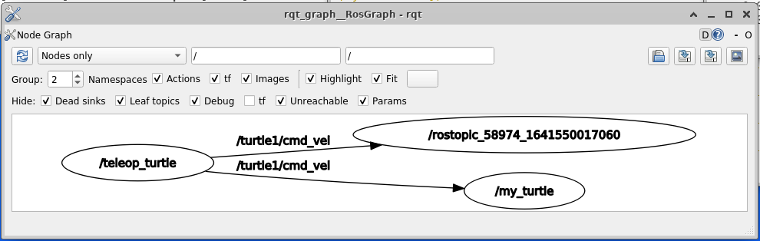

$ rostopic list -v

rostopic pub -1 /turtle1/cmd\_vel geometry\_msgs/Twist -- '[2.0, 0.0, 0.0]' '[0.0, 0.0, 1.8]'

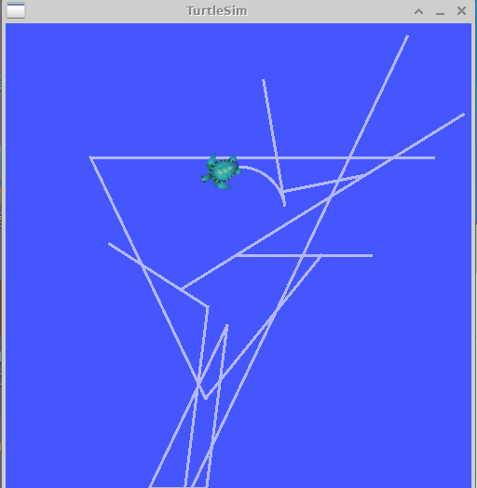

* $ rostopic pub /turtle1/cmd\_vel geometry\_msgs/Twist -r 1 -- '[2.0, 0.0, 0.0]' '[0.0, 0.0, -1.8]'

$ rosservice list

$ rosservice call /clear

$ rosservice type /spawn | rossrv show

$ rosservice call /spawn 2 2 0.2 ""

$ rosparam list

$ rosparam set /turtlesim/background\_r 150

$ rosservice call /clear

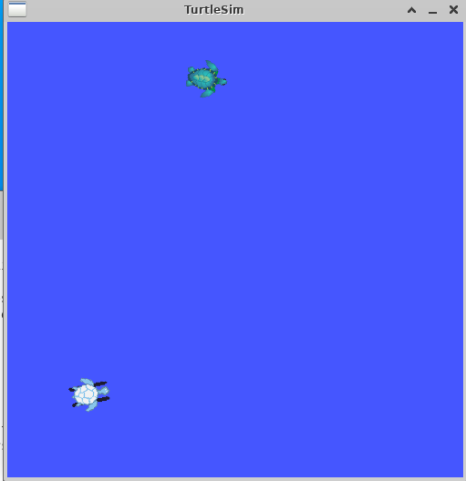

$ rosparam get /turtlesim/background\_g

$ rosparam get /

## Using rqt\_console and rqt\_logger\_level

$ rosrun rqt\_console rqt\_console

$ rosrun rqt\_logger\_level rqt\_logger\_level

$ rosrun turtlesim turtlesim\_node

* rostopic pub /turtle1/cmd\_vel geometry\_msgs/Twist -r 1 -- '{linear: {x: 2.0, y: 0.0, z: 0.0}, angular: {x: 0.0,y: 0.0,z: 0.0}}'

### Using roslaunch

$ cd ~/catkin\_ws

$ source devel/setup.bash

$ roscd beginner\_tutorials

$ mkdir launch

$ cd launch

Now let's create a launch file called turtlemimic.launch and paste the following:

[切换行号显示](http://wiki.ros.org/ROS/Tutorials/UsingRqtconsoleRoslaunch)

<launch>

<group ns="turtlesim1">

<node pkg="turtlesim" name="sim" type="turtlesim\_node"/>

</group>

<group ns="turtlesim2">

<node pkg="turtlesim" name="sim" type="turtlesim\_node"/>

</group>

<node pkg="turtlesim" name="mimic" type="mimic">

<remap from="input" to="turtlesim1/turtle1"/>

<remap from="output" to="turtlesim2/turtle1"/>

</node>

</launch>

$ roslaunch beginner\_tutorials turtlemimic.launch

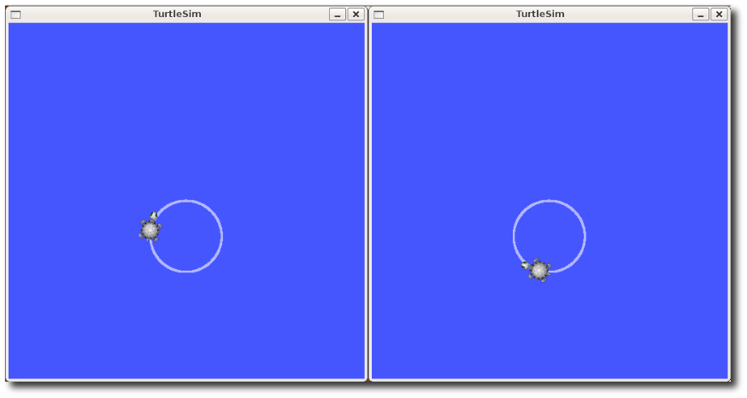

* $ rostopic pub /turtlesim1/turtle1/cmd\_vel geometry\_msgs/Twist -r 1 -- '[2.0, 0.0, 0.0]' '[0.0, 0.0, -1.8]'
* We can also use [rqt\_graph](http://wiki.ros.org/rqt_graph) to better understand what our launch file did. Run [rqt](http://wiki.ros.org/rqt)'s main window and select Plugins > Introspection > Node Graph:
* $ rqt

